|  |  |
| --- | --- |
| Project Title: Gesture – based tool for Sterile browsing of Radiology images | Team ID: PNT2022TMID39878 |

**ARCHITECTURE DIAGRAM FOR A GESTURE – BASED TOOL FOR STERILE BROWSING OF RADIOLOGY IMAGES**



Prediction

* 1.Resize
* 2.Relocate
* 3.Blur
* 4.Flip

TRAINING TEST DATA

FEATURE CLASSIFICATON

       

USER INTERFACE MODEL DATA PREPROCESSING FEATURE EXTRACTION FEATURE SELECTION EVALUATION IMAGE

 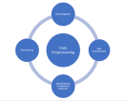  

USER GENETIC ALGORITHM TESTNG DATA

 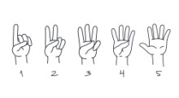

WEB CAM HAND GESTURES